The impact of weather on stock market performances

**Ronny Kaynan**

Grad 699-90: Applied Project in Analytics

Instructor: **Olga Scrivner**

June 2018

**Abstract**

In my paper I tried to explore the impact of weather on the stock market. Do colder days have lower returns than warmer days?

It is a known fact that weather has an impact on people's mood and behavior(Kang, Jiang, Lee, & Yoon, 2010). My assumption was that colder days make people sad and therefore more bearish or pessimistic in their treading while sunny hot days make people happier and more bullish or optimistic. I was evaluating whether this assumption holds in the New York stock exchange. Many studies tried to answer this question and I used the literature to guide my research. My main goal was to determine if there is correlation between warm days and higher returns. My research included the NYSE index daily returns for a period of several years and compared it to weather data of those same days. I conducted different statistical analysis to determine correlation (see data and analysis section for more detail).

The main obstacle is the fact that not only New Yorkers are trading the New York Stock exchange, and those people may live in areas with a different weather, which in turns have different impact on their behavior. However, my assumption was that this is a small segment of the traders in the New York stock exchange. My hope was that my research would provide another criterion to evaluate while trading.

Based on the results of the analysis I concluded that weather had no impact on the New York (NYSE) stock exchange. While there were a few outliers, such as hot days in the summer, cold days in the summer, and cold days in the spring, that showed slightly stronger relation, they were still not as significant nor very common. Even though my analysis did not show impact in the New York stock exchange it is not necessarily true to all markets. My literature review shows that in some markets weather does have significant impact on stock market returns. There can be multiple reasons for my results. First, as the largest stock exchange in the world, New York attracts people from all around the world and some people may trade from different locations. As a result, those people may experience different weather that that have a different impact on their trading behaviour. Second, New York also attracts the most talented and trained traders in the world. Those traders may be well educated and make “cold” decisions, regardless of their mood. Finally, through not likely, weather may have different impact on different people. While some may have negative moods in a cold rainy day, others may flourish

**Introduction**

It is a well-known fact that weather has a tremendous impact on peoples’ behaviors and moods (Kang, Jiang, Lee, & Yoon, 2010). In addition, weather impacts our annual plans – for example, in the summer people are more likely to choose a vacation on the beach, while in the winter they are more likely to choose a ski resort. Since traders are no different from the rest of the population, they may be affected by changes in weather. The changes in traders’ mood due to weather may translate into higher or lower trade volumes in the stock market and increase or decrease returns. In my work I will research the effects the weather has on the New York stock exchange results.

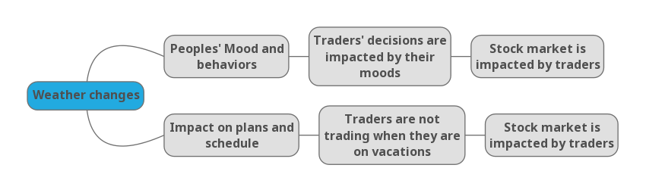

This topic was researched by different scholars around the world. In some cases a correlation was found while in others the results were not conclusive. The New York exchange is the biggest stock exchange in the world and results of this type of study may help traders and other investors to make some determination of the market direction based on the weather. While I don’t think that traders make their decisions solely based on their mood, I’m convinced that they are impacted by it. And since weather has an impact on their moods it may alter their behavior, including trading decisions.

My purpose in this analysis is to determine the extent to which traders are impacted by the weather. This will help me and other traders to make buy/sell decision. For example, if the research shows that during a cold day stocks tend to lose value, I would probably postpone stock sell off (if possible) for a sunny day, and vice versa.

The main question this research will answer is: How is the New York stock market impacted by weather in the Northeast? Do colder days have lower returns than warmer days?

Key terms: Stock market/ Stock exchange, Weather effects/ weather impact, trading volume, stocks returns, total equity

**Hypothesis**

My hypothesis is that colder days will have lower returns in the stock market and that warm days will have higher returns. The underlying assumption is that weather impacts peoples’ moods. I assume that sunny warm days improve moods while cloudy cold days cause bed mood. Since traders behave like the rest of the people they are affected by the same external factors. Therefore, if the assumption holds, traders will be happier in warm days, and grumpier (or less happy) on cold days. This will have a direct impact on their trading habits. My hypothesis is that during warm days, while traders are happier, they will trade more optimistically and show higher returns. My hypothesis is supported by half of the articles in the literature review.

**Literature review**

In the literature review I took the chronological and topical approach. The topics my review is addressing are 1) the impact of weather on peoples’ moods and 2) the impact of weather on different stock markets around the world. Within each topic I introduced the research from the most recent one to oldest.

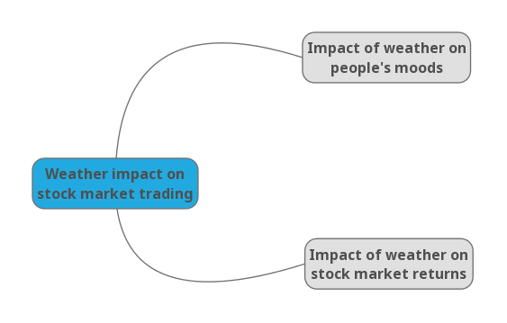

Impact of weather on peoples’ mood:

In the article “**Weather and Helping: Additional Evidence of the Effect of the Sunshine Samaritan**” (Guéguen & Lamy, 2013), the writers examine how weather changes the way people are helping others. The researchers started with the assumption that “Pleasant weather conditions (i.e., sunshine) favor positive social relationships and improve mood”. Based on this assumption, they wanted to examine the effect of sunshine on spontaneous helping. The researches designed a field study that examined how people react to the same issue in a different weather. In the experiment, men and women dropped a glove on the ground while walking. They found that people who were passing by were more likely to pick up the glove and return it to those who dropped it on a sunny day and are more likely to ignore it in a cloudy day. The experiment was taken place in predominantly cloudy or sunny days, with relatively similar temperature and no rain. The researchers used four women around the age of 21 and four men around the same age, addressed as the confederates. They were dressed in a typical outfit for people their age and were given instructions to drop the glove only if the passing by pedestrian is from the relevant test group, namely a man or a woman who was approximately 20–50 years old. The confederates were also instructed not to drop the glove in front of a person who was distracted (e.g. standing in front of a store). The results of this study supported the assumption that during sunny days, people tend be more helpful. Since all other parameters were equal, the researchers concluded that sun was the determining factor. They assumed that weather has an effect on people, and that during sunny days people are happier. This article supports my hypothesis that weather has an impact on peoples’ moods and may impact the way they trade in the stock market.

Another article that tries to evaluate how weather impacts people based on the amount of time they can spend outside and the type of activities. The researchers hypothesis in **The Contingent Effects of Weather on Mood and Cognition** (Keller et al., 2005) hypothesis was that people would have higher moods if they can spend time outside. Therefore, too hot or too cold days would result in a low mood, while nice average sunny days would result in higher moods. The researchers conducted a study in Ann Harbor between April and June. They invited 97 paid subjects (54 women and 43 men) to answer a survey that addressed their moods. The subjects were not aware of the purpose of the study when they were filling the survey. Subjects were only told about the weather impact during the debriefing, after they already answered the questions. The participants responded to a newspaper advertisement. The research was done around mood valence, meaning the intrinsic attractiveness/"good"-ness (positive valence) or averseness/"bad"-ness (negative valence) of an event, object, or situation. The results of this study did not show direct correlation between temperature and moods. However they we concussive of the correlation between time spent outside and high mood. Since people tend to spend more time on average sunny days outside, they tend to have better mood during this time. This is an indirect support for the hypothesis that people have higher moods during warmer days. In this article the researches addressed two similar studies they conducted with different test groups and I different period of times. In study number 2 the researchers tried to manipulate the time spent before the survey and after to see how that would impact their moods. The findings of this survey were in line with the finding from the first study – when people spend more time outside in average sunny days they tend to have higher moods. In study number 3 the researchers tried to understand the results across different seasons. Their findings were most significant during the spring, while in other periods they were not significant. This study help in understanding how weather impacts people, and I will try to apply similar approaches in some of my analyses.

Impact of weather on the stock market:

In a research on **the impact of Bangkok weather on the stock market in Thailand**, (Khanthavit, 2017), Khanthavit claims that conducting an analysis on the effect of weather on the stock market return presents many challenges. Many of the researches in this area have issues, or problems, with the analysis including: incorrect fixed-effect assumption, missing data, omitted variable, and error in variable. This study proposes and approach that addresses these problems simultaneously. While some previous studies considered various variables, they only evaluated those variable one at a time. Khanthavit however believes that there is a correlation between the different variable. Therefore, she looked at those variables simultaneously. She also addressed the problems mentioned above with methodologies that were used in previous studies. Here too, each study addressed only a portion of the problems and did not solve for all of them. Khanthavit used daily data for her analysis. Stock market data included closing SET, SET 50 and MAI indexes. These sets of data are comprehensive representation of the stock market in Thailand. Important to mention that majority of the trade was conducted by small, individual investors. Onlu small portion was traded by institutions and international investors. The weather data included air pressure (hectopascal), cloud cover (decile), ground visibility (km), rainfall (mm), relative humidity (%), temperature (°C) , and wind speed (knots per hour). The Bangkok weather data are measured by the Thai the Meteorological Department’s weather station at Don Muang Airport. Weather data was obtained for the same period of 25 years and compared with stock market data on a daily basis. Khanthavit found that only some investors are sensitive to weather effects. Those are the less experienced or knowledgeable investors. While in many markets small, individual investors are considered noise, in the Thai stock market that was evaluated they were the majority of the traders. Based on the finding, Khanthavit concluded that the market is not completely and is affected by peoples’ moods. These findings support my hypothesis. However, if trader mix is different in the New York Stock Exchange, the result may look different.

In his article post “**Weather vs. the Stock Market”** (Ong, 2016), Ong developed an analytical tool that examine the impact of weather on stock prices. He mentioned that previous studies on the matter are divided in their conclusion. While some argue there is absolutely no correlation, others claim there is correlation between weather and stock market returns. He used Yahoo finance for stock exchange data between 2013 and 2015. For weather data he created a file using Weather Underground. The criteria he used were Maximum Temperature, Maximum Humidity (%), Maximum Wind Velocity (mph), Maximum Visibility (miles), Cloud Cover (oktas), and Rain or Precipitation (inches). Ong’s conclusion was that there is definitely a correlation between weather and stock exchange. However, it is very important how we use and interpret the data. Ong sites that one must address the seasonality impact of the results.

In the study “**Do Weather-Induced Moods Affect the Processing of Earnings News?”** (Madsen & Piotroski, 2016)**,** the writersinvestigated the relationship between unpleasant weather, mood, and worker productivity. They examined whether weather-induced negative moods impair professional stock market participants’ responses to information events. Their approach was to examines how local weather conditions affect geographically dispersed equity analysts’ responses to earnings announcements. Since earning calls are preschedule, and well defined there should no be difference in reaction to similar news. However, if it does happen, there must be an external factor that caused it, such as weather. The writers used over 650,000 different analyses in around 140 cities in the US and tried to correlate those with weather. The results of their analysis supported the hypothesis that weather had an impact on the analysts conducted analyses after earning calls. Although there was no way of directly correlate the information, these results support my hypothesis that weather has an impact on the stock market.

In an article examining the impact of weather on the Indian stock exchange (Vijayakumar, Dharani, & Muruganandan, 2015), the researchers evaluated the impact of weather on the volatility of the Indian stock exchange. They used daily data for a period of 6 years (2008-2013). The data included daily closing price of the S&P CNX Nifty index as well as weather data, which included mainly temperatures in the three main regions. India’s size and special climate in each region were taken into consideration in the analysis. In the bigger cities, where trade is taking place, one region may be very hot while another can be cold, one area can be dry whereas another can be very rainy. These differences may have impact on overall trade. Using different models, the writers concluded that weather was influencing investors in India and hence stock returns were impacted. Hot days tend to have higher returns. This article supports my hypothesis that weather impacts stock market returns.

**A study of the stock markets in Turkey, Belgium, France and Greece** (“Testing Weather Effect Anomalies : Time Varying Evidence from Selected Stock Markets Feyyaz ZEREN * Fatih Burak GUMUS,” 2015)**,** found a correlation between changes in weather and trading behavior only in some periods of the time. This suggests that people are impacted by the weather. However they do not always react to weather effect. It is important to note that the author did not mention how the weather impacts returns (e.g. high temperatures support higher or lower return). To conduct this study the researchers addressed causality in time zones evaluating the 4 countries – Turkey, Belgium, France and Greece. The data points used were daily temperature, humidity and stock returns for a period of ~13 years. They found meaningful impact on stocks that are directly affected by the weather, such as agricultural stocks. This study support my analysis that weather impacts peoples’ trading habit, but it does not give a direction as for what the impact is.

The study **‘Weather effects on the returns and volatility of the Shanghai stock market’** (Kang et al., 2010) evaluated the impact of weather on the Shanghai stock exchange. To do that, the researches chose to address two different populations – local traders and foreign investors. They assumed that local traders will be more sensitive to the local weather while foreign investors will trade more logically. The researchers used daily stock exchange result over a period of 10 years. In china, local investors can trade A type stocks, while foreign investors can only trade B type stocks. This distinction made it possible to analyse each group separately. The daily weather data was obtained from China Meteorological Administration, and the researchers used temperature, humidity and sunshine information. They normalized data based on the season. For example, while 18 degrees Celsius is considered cold in the summer, it is relatively warm for the winter, so they converted the data to dummy variable representing warm or cold. Using several analyses on the data, the researchers found that weather has a strong impact on peoples’ behavior and in turn on stock market prices and volatility. They concluded that weather affected both groups and was a considerable factor in trading decision. The results of this article fully support my hypothesis.

**An empirical research on the Australian market** (Worthington, 2009) examined the impact of weather on the Australian stock market over the period of almost 50 years. The research conducted a simple regression analysis using the daily return in the Australian stock exchange, and corresponding weather parameters. The eight different weather parameters used are precipitation, evaporation, relative humidity, maximum and minimum temperatures, hours of bright sunshine, and the speed and direction of the maximum wind gust. The researchers found that found that while weather does impact the peoples’ moods it had no impact on the stock market return. The Australian market is more mature than some of the others in my literature review and traders are probably more trained in trading. Therefore, they are more likely to trade based on a strategy they developed than their moods. This article refutes my hypothesis, and even though it is only one among many that supported the hypothesis, I tend to believe that the Australian market will show similar results to the New York stock exchange because they are both mature with similar business environment.

In their study of the **‘Weather effects on returns: Evidence from the Korean stock market’** (Yoon & Kang, 2009), Yoon and Kung researched the impact of weather on stock market before and after the financial crisis of 1997. The researchers recognized that “weather conditions influence an individual's emotional state or mood, which can create the predisposition to engage in particular behaviors. The most essential finding in this regard is that, across a wide range of weather variables, good (bad) weather conditions induce positive (negative) mood states, which adulterates or mitigates the process of rational or optimal decision-making. Based on these perspectives, behavioral finance theory has recently argued that, to some degree, stock market anomalies may be the consequence of relevant weather factors. The existence of a weather effect in financial markets has raised some questions as to the validity of the efficient market hypothesis (EMH), which assumes that market prices always incorporate the best available information regarding fundamental values”. For the analysis Yoon and Kung used the daily closing prices of the Korea Composite Stock Price Index 200 (KOSPI 200) for a period of over 15 years. The researches assumed that the KOSPI 200 index is reflective of the overall market performance of the Korean stock market because its constituent shares cover approximately 80% of domestic market capitalization. For weather data they explored the daily weather data for temperature (TEMPER), humidity (HUMID), and cloud cover (CLOUD) in Seoul for the same period, obtained from the Korea Meteorological Administration. Weather variables are not economical explanatory variables. Therefore, to assess the relationships between stock returns and weather variables, the researchers converted the weather variables to dummy variables. Additionally, the weather variables are highly seasonal in Seoul. Increases in temperature and humidity are linked to summer weather, whereas winter months are associated with cloudier weather. To overcome these gaps the researchers used a 21-day moving average and its standard deviation to adjust the three weather variables. Yoon and Kung conducted the analysis in two steps. First, they conduct a simple t-test to check for differences in returns between the two extreme weather conditions for each weather variable. Second, they evaluated the influence of the weather dummy variables on stock returns. Their findings show that before the crisis humid days with temperatures above average had lower returns, and colder days had higher returns. After the crisis weather was less significant, however extreme hot days still showed lower returns and extreme cold days had higher returns. This study results in exactly opposite outcome than my hypothesis before the crisis. However, the study does not support any correlation between changes in weather and stock market returns after the crisis. This may teach us that markets become more efficient as they mature.

In the article “**Does Weather Affect Stock Returns Across Emerging Markets”** (Zadorozhna, 2009)**,** the writeraddresses the impact of weather on stock markets across Eastern Europe. The analysis examined 13 neighboring markets with cultural similarities. In addition, those emerging markets have higher growth rates than developed markets, and as such had not been studies before. Zadorozhna used daily weather data of capital cities of the relevant stock exchanges. The countries analyzed showed high volatility in the stock exchange, as expected from emerging markets. Zadorozhna used the following weather parameters: temperature, cloud cover, atmospheric pressure, wind, precipitation, visibility and humidity measured at 12 pm daily. The results of this study indicate small impact. In Ukraine for example only extreme cold temperatures had impact on returns. She also compared the data with relation to the NYC stock exchange. Overall conclusion is that even though there are minor a difference between different countries, weather does not have a significant impact on stock markets. This study has an interesting approach to look for in my analysis. However, considering the huge differences between emerging markets and developed markets, an independent analysis must be conducted.

In the article ‘**Are stock market returns related to the weather effects? Empirical evidence from Taiwan**’ (Chang, Nieh, Jing, & Yang, 2006), the writers study how weather affects human moods, and particularly how moods affect investors’ behavior in the stock market. They based their study the stock exchange in Taiwan. The researchers used daily weather data for temperature in Celsius degrees, humidity and cloud cover in Taipei city for a period of 6 year. All weather data were taken from the Central Weather Bureau of Taiwan. They used stock index data from the AREMOS database and included the daily closing index of the Taiwan stock market with the same time length as the weather data. Following the conventional approach, daily stock returns were calculated as the logarithmic difference in the daily stock index. The researchers found that the distribution of stock returns is non-normal through the statistics of skewness and kurtosis as well as the Jarque-Bera test. As for weather, the researchers determined that the distribution is non-normal for humidity, and cloud cover based on the statistics of skewness and kurtosis and the Jarque-Bera. The writers found that significant linear and non-linear dependencies exist in the weather factors and the stock market returns in Taiwan. The writers concluded that there is a correlation between extreme weather condition and lower returns in the stock market in Taiwan. Based on their research, extreme hot summer days (above a threshold determined by psychologists) or extreme cold days (below a threshold determined by psychologists) have a significant impact on peoples’ moods and in turn on their behaviour. These days cause people to be impatient and agitated and resulted in lower returns in the stock market.

In the article ‘**Weather, Stock Returns, and the Impact of Localized Trading Behavior**’ (Loughran & Schultz, 2004), Loughran and Schultz examined the impact of sunlight (or lack of sunlight) on peoples’ moods and the results for the stock market. The writers decided to address to Nasdaq stocks because they believe Nasdaq traded stocks returns are particularly likely to be affected by local weather conditions. Nasdaq-listed companies tend to be smaller than NYSE companies and research shows that that the local bias of fund managers is more severe for small capitalization stocks than large ones. Their source for weather data was the International Surface Weather Observations dataset provided by the National Oceanic and Atmospheric Administration. This source includes hourly observations of cloud cover for weather reporting stations. Sky conditions are defined as clear, scattered clouds, broken clouds, or overcast. They calculate the average amount of time each day each condition is in effect using observations from 8:00am – 4:00pm New York time. Cloud cover is examined for these hours because they were concerned with cloud cover while the market was open for trading. In most cases, there was more than one reporting station near a city. To be consistent for all locations, they used cloud cover observations taken at the city's major airport. To get more accurate results, the researchers addressed localized trading. First, they showed that intraday patterns in trading vary according to the time zone of the company headquarters. Trading in firms based in Alaska or Hawaii is far lower when it is morning in New York, and residents of those states are asleep, than later in the day. The dip in trading that corresponds to lunch time on the East Coast is far more pronounced for firms with headquarters in the Eastern time zone than on the West Coast. Second, snowstorms in a city affect the trading volume of stocks based there. For most of the cities they sampled, if snow was falling early in the day, investors may have had to shovel snow, dig out cars, and take longer to get to and from work. These investors may simply not have time to trade stocks on that day. If snow falls at night, trading on the next day may also be affected. In cities experiencing blizzards, they found that trading volume fall by more than 17% on the day of the storm and by almost 15% the following day. Trading volume of stocks based in other cities was unaffected by the local blizzard conditions. Third, holidays affect trading volume of stocks in various cities differently. They look at trading volume on Yom Kippur, an important Jewish holiday when the stock market remains open. While they found that trading volume drops on Yom Kippur for stocks based in most cities, the effect is significantly stronger for companies based in cities with higher percentages of Jewish residents. Loughran and Schultz did not find significant correlation between weather and retruns in the stock marker. However, they did find a significant correlation between sunny days and positive returns and on the flip side negative returns on cloudy days. While this does not completely support my hypothesis, this shows some impact of weather on peoples’ moods and in turns on their financal behaviour.

In the article **“Good Day Sunshine: Stock Returns and Weather”** (Hirshleifer & Shumway, 2003), the writers examined the impact of morning sunshine on stock returns across 26 stock exchanges around the world. The writers used daily weather data from the *Institutional Surface Weather Observation* (ISWO), obtained and sold by National Climate Data Center. Since their hypothesis was around sunshine they mainly used the sky cover (SKC) parameter for the analysis. As for stock exchange data the writers used they collected daily data for all cities that had information between 1988 and 1997. Their conclusion was that sunshine is highly correlated with higher returns. The writers claimed that while this is not a risk free strategy, it can help investors shape their daily decisions when trading. These results support my hypothesis that weather has an impact on the stock exchange.

E. Saunders’s **“Stock Prices and Wall Street Weather”** research (Saunders, 1993), rejected the hypothesis that weather impacts returns on stocks. He found that changes were the same on sunny and cloudy days. The writers explained the difference before and after the crisis by the different environment. After the crisis more strict regulations were implemented, including limits on international investor. This may indicate that the reason for lower volatility is the result of different factors, and that weather still has an impact on trade.

**Data**

To understand the relationship between the stock market performances and the weather conditions I collected daily stock market prices and weather data between the years 2006-2013. I used the NYSE index daily returns for a stock market prices and daily temperatures for daily weather, including minimum, maximum and average temperatures.

The NYSE index data set is available in different websites such as Yahoo Finance, Google Finance, Bloomberg, etc. I chose to use the data from Yahoo Finance as it is one of the most reliable and accessible website for this type of information. The data points that I used in this analysis were volume of trade, open rate, close rate, and average rate. The volume was used to understand the different trading patterns in hot vs cold days. This helped in understanding the significance of the analysis. For example, if the market had lower return on colder days, but at the same time very low average of trading volume, this may be an indication that only a small number of transactions impact the trend and weaken the conclusion. While I generated many data points for the analysis, I only presented daily change to analyse the impact of the weather. This parameter considers the opening and closing of any given day and may give a better correlation between the weather and the trading patterns throughout the day. Big changes were already adjusted in the opening rate, and the change from closing was probably caused by factor of the specific day (e.g. weather, announcements throughout the day etc.). Since planned announcements usually happen after trading hours my assumptions that only a small number of announcements were made during the day, and those would be identified as abnormal in the cluster analysis.

Daily weather data set was a bit more challenging to find as it varies depending on the station that was measuring the temperatures each day. My source for this data set was NOAA – National Center for Environmental Information. Since I assume that traders were impacted throughout the day, I used the average temperature, the lowest temperature and the highest temperature of each day. While comparing the three I realized that they have similar behaviour and would have similar impact on my statistical analysis. Average temperature helped in comparing the days in a simple method.

**Methodology**

I conducted multiple statistical analyses to determine whether there is a relationship between the two data sets. The different analyses were done on the entire data set, and subsets of the datasets. The first subset I used was seasons. This divided my analysis to additional four sections. In addition, I identified hot, cold and average days for each subset of the analysis. To identify hot cold and average days for the overall analysis I determined limits. Cold days were days with temperature of less than 45 degrees Fahrenheit, and hot days were days with temperatures above 79 degrees Fahrenheit. The rest of the days were average. However, by doing that I did not address the way people feel as compared to their situation. For example, if the spring weather is 60 degrees Fahrenheit on average, a 68-degree day would be warm for me. Therefore, to determine hot or cold days in the seasonal analysis I calculated the average temperature for the season plus/ minus 7 degrees. Everything below was considered cold while everything above was considered hot. **Table 1** below includes a summary with temperature distribution and number of hot, cold and average days

**Table 1 – weather data summary**

|  |  |  |  |  |  |  |
| --- | --- | --- | --- | --- | --- | --- |
|  | **Temperature distribution** | | | **Number of days** | | |
|  | **Average** | **Max** | **Min** | **Hot** | **Cold** | **Average** |
| **Summer** | 73.2 | 89.0 | 55.0 | 45 | 51 | 371 |
| **Winter** | 32.8 | 60.0 | 10.5 | 76 | 69 | 264 |
| **Autumn** | 55.6 | 82.5 | 30.5 | 122 | 121 | 243 |
| **Spring** | 51.7 | 79.5 | 15.0 | 110 | 111 | 214 |

For each of the groups mentioned above (overall dataset, summer, winter, spring and autumn) I developed a similar set of analyses to understand the overall impact, and the impact by season. Based on the results and the structure of the data I conducted more in-depth analyses in specific cases.

Overall trends – I started with laying out the overall trends in the market between 2006 and 2013. Chart 1 examines the trends in weather, while chart 2 look into the daily changes of stock prices in percentages. This helped in understanding patterns and direct the analysis. For example, based on the trends I realized that different seasons may need different considerations. And while in the winter 60 degrees may be warm, in the summer this means cold.

Cluster Analysis – was conducted for each of the different groups. In this analysis I used the daily change in price and the temperature. I used the tag of Hot, Cold, and Average to color code the different clusters and added a trendline. This analysis gave a visual output of the relationship between temperatures and daily change in the stock market.

Second Cluster analysis – was conducted to find relationship between the change in weather (percentage from the previous day) and the change in price. This analysis was looking to find whether a one percent change in the temperature has a similar (or opposite) change in stocks prices.

Other Clusters – were conducted for a dipper analysis within a season. In the summer I conducted an analysis for hot days only, and another for cold days only. In the spring I conducted an analysis for cold days only as well.

Correlation – between volume, average temperature and daily change in stock price. This gave an indication for the strength of the connection between these three parameters as well as the direction. Correlation that is closer to 1 would indicate strong correlation in the same direction (e.g. as temperature increases so does stock market), while correlation that is closer to -1 indicates strong correlation in the opposite direction (e.g. temperature increase result in price decrease). If correlation is closer to 0, there is not strong correlation, so the chosen parameters do not indicate a strong connection.

Regression and Anova – used the weather as the independent variable. Volume and change from opening were the dependent variables. This analysis generated the equation to predict the change in price as well as the volume. The regression generated the R squared which is an indication for the strength of the results as well as the standard deviation. The Anova analysis generated the parameters for the equation and the level of confident of the results. This analysis also generated the t and p statistic values that can help in finding the level of confidence in the model.

Seasonal Regression and Anova – checking the relationship within seasons and day to day change in the market (checking for colder days in the winter, hot in the winter etc.). This analysis was built on the previous analysis. Here I tried to evaluate how weather is impacted within a specific season. By doing that I isolated the seasons and identify hot and cold days that are relative to the season. The results showed the different impact seasons have on traders. For example, a relatively warm day in the winter may be a bless that makes people happy, while a hot day in the summer may be unpleasant and cause traders to be more impatient and agitated, therefore more pessimistic in their trades.

Challenges – The main challenge in understanding the New York stock exchange is that many people from around the world are trading there. The trading data may come from people who live in areas with a different weather, which in turns have different impact on their behavior. However, some studies show that the majority of traders are trading from New York. My assumption was that only a small segment of the traders is not trading from New York, and will not have significant impact on the results.

**Results**

In chart 1 below we can see that weather has very consistent trends. Weather fluctuating with low temperature during the winter and high during the summer. Not many outliers were observed, and this consistency makes the weather a good point of reference. One thing I realized from chart 1 was that different seasons need different analysis. Considering that the difference between the highest temperature in the summer and the lowest in the winter is almost 100 degrees, it would have been wrong to not account for these differences.

**Chart 1 – weather summary**

Chart 2 below lays out the stock prices across time. The results of this table are very different from the results of the weather. Stock market does not seem to have seasonality and my assumption is that other factors impact the volatility. The irregularity of the stock market makes it harder to predict or use. In my analysis I tried to predict this volatility through daily changes in weather.

**Chart 2 – Stock Market Summary**

Chart 3 looked at the daily change in stock prices as a function of the average temperature. Days with temperature above 70 degrees Fahrenheit were considered hot, temperature below 45 degrees were considered cold and the rest were average. The results of this analysis do not support my hypothesis. The trendline is almost horizontal, which indicates very low correlation. Furthermore, I tried to look at specific group (e.g. hot, cold, average) but their trendline was flat as well.

Then I conducted correlation in table 2, and regression and anove in table 3. The parameters I used were daily average temperature as the independent variable and volume and daily price change as the dependent variable. The analysis shows very low correlation, close to zero. The correlation to volume was about -12.5% which is still very low, but may indicate opposite relation between volume and weather. This means that the higher the temperature the lower the volume. The regression was very weak with R square close to zero. So were the anova results, whit high P value – indicating high probability that the results are by chance, and low degree of confident.

**Chart 3 – Cluster of Return and Weather**

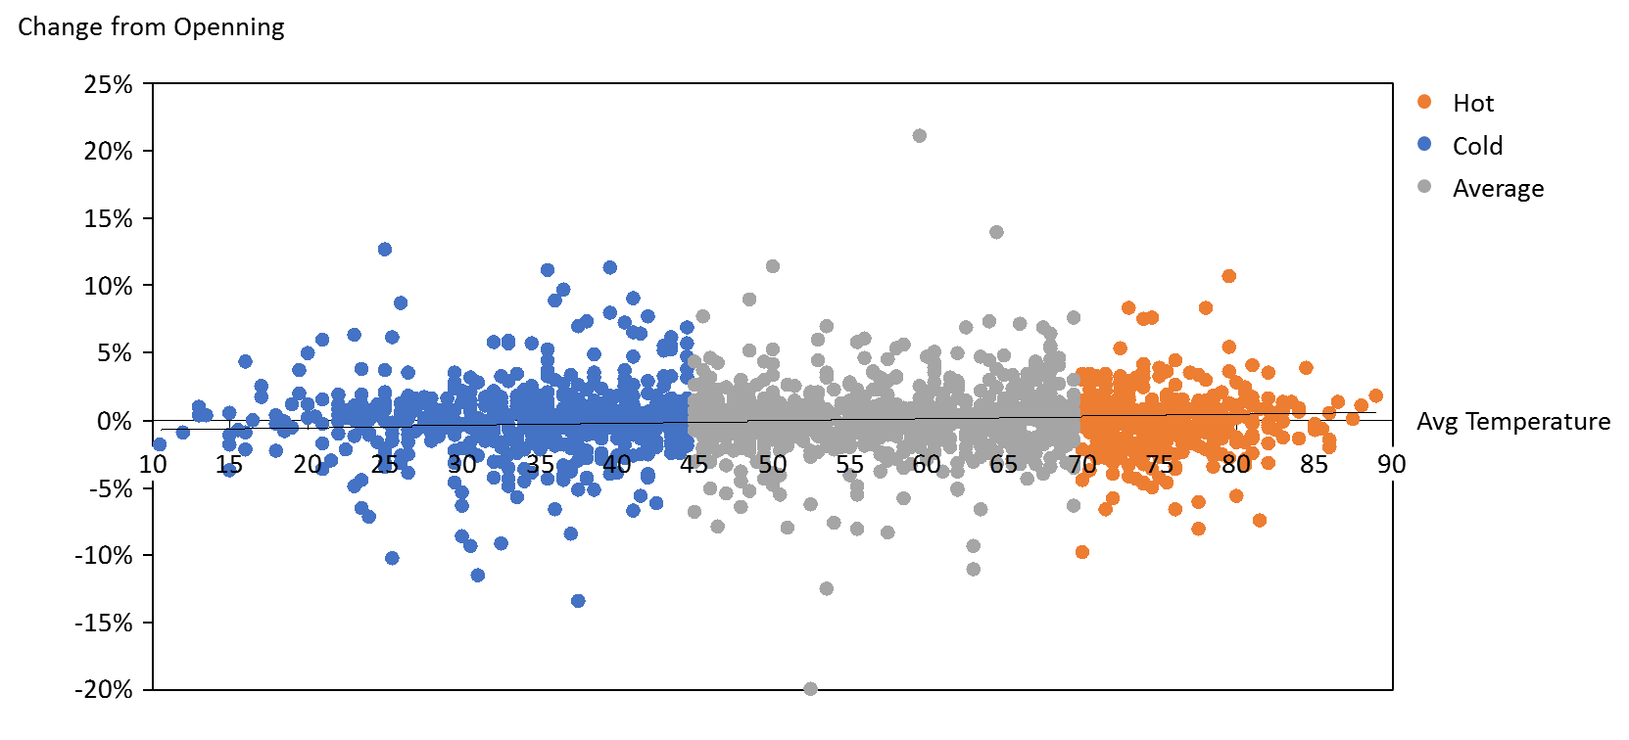

**Table 2 – Volume, Daily Change and Average Temperature Correlations**



**Table 3 – Volume, Daily Change and Average Temperature Regression and Anova**



The next set of analyses I made for the data as a whole were similar to the previous set but this time I examined the change in price against the change in temperature (percentage) in chart 4, table 3, and table 4. These analyses had similar results with no correlation between weather and stock prices was found.

**Chart 4 – Change in Temperature and Change in Price Cluster**

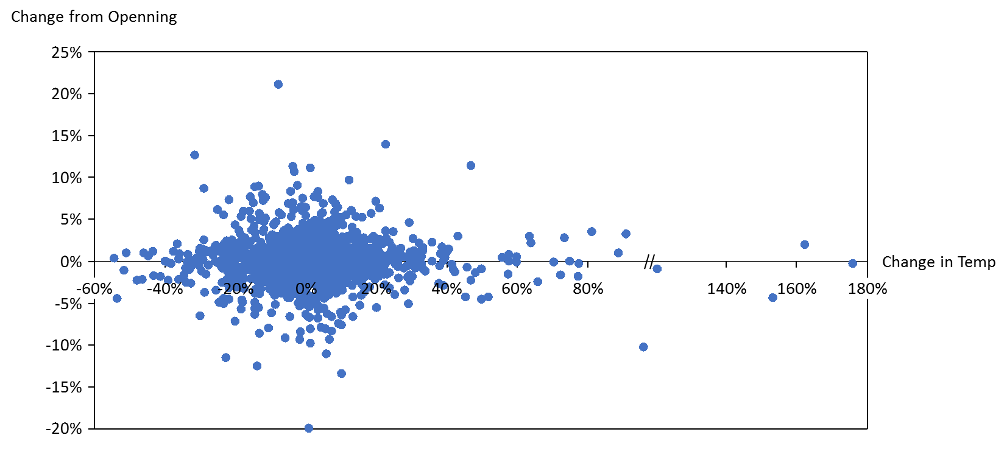

**Table 3 – Change in Temperature and Change in Price Correlations**



**Table 4 – Change in Temperature and Change in Price Regression and Anova**



As various analyses on the data as a whole showed no correlation, which meant that I could not prove that weather has an impact on stock prices, I decided to take a different approach and segmented the data set by seasons. The next several analyses include similar charts and table for the four seasons.

The summer analysis as a whole did not find a relation between the weather and stock prices. Starting with a cluster analysis in chart 5.1, the price change distribution was almost identical below and above zero for any temperature. The correlation in table 5 resulted in similar conclusion – very low relation found between temperature and the stock prices changes. Regression and anove in table 6 also did not support my hypothesis. However, in the summer analysis I’ve noticed that if looking only at hot days or only at cold days there is a stronger regression line. Charts 5.2 shows that on days that were identified as hot, there is a stronger positive relation between weather and stock prices. This indicates that the hotter it gets the higher the stock prices will be. On the other hand, colder days had stronger negative connection. This indicates that on cold days, the colder it gets the lower prices were.

**Chart 5.1 – Summer Cluster of Return and Weather**

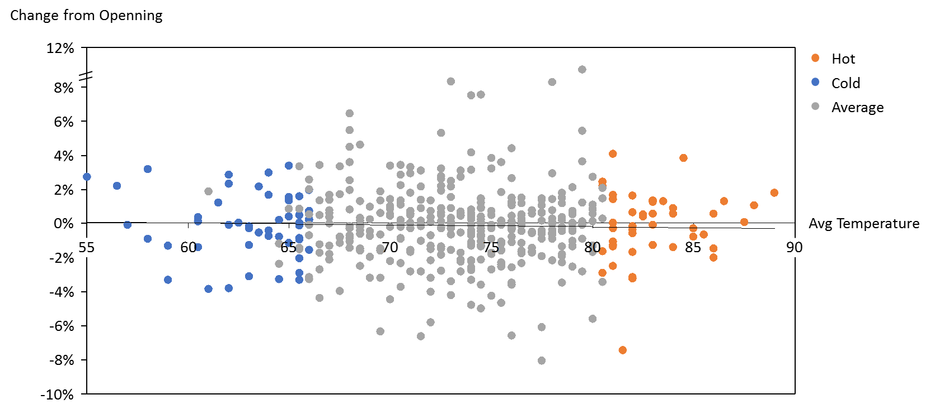

**Table 5 – Summer Change in Temperature and Change in Price Correlations**



**Table 6 – Summer Change in Temperature and Change in Price Regression and Anova**



**Chart 5.2 – Summer Cluster of Return and Weather – Hot Only**

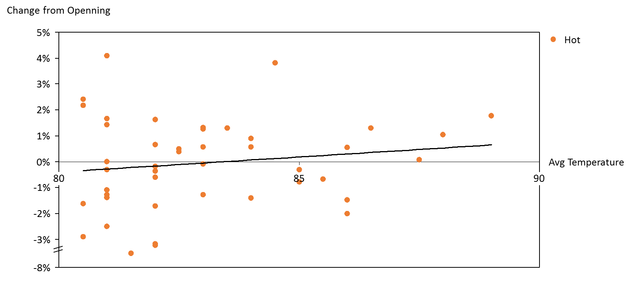

**Chart 5.3 – Summer Cluster of Return and Weather – Cold Only**

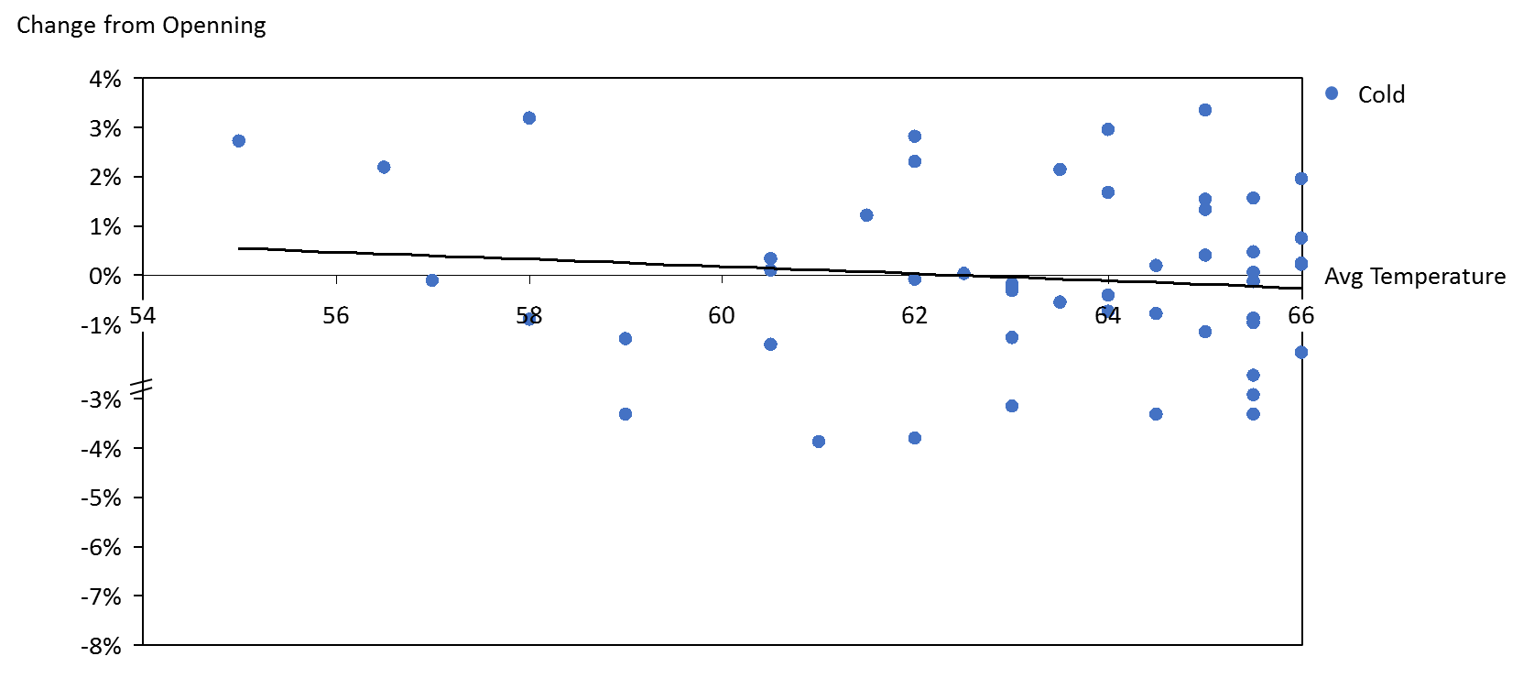

Winter results were in line with the rest of my results – no correlation between weather and stock prices was found. Cluster analysis in chart 6 shows even distribution of changes in stock market for any given temperature. The results are so even that it is hard to identify the trendline. Table 7 shows the result of the correlation analysis. Here too, correlation was very at close to zero. Table 8 includes the regression and anova results. The regressions with close to zero R squared indicates a very low connection between weather and stock prices. So does the anove with high P value and low degree of confident.

**Chart 6 – Winter Cluster of Return and Weather**

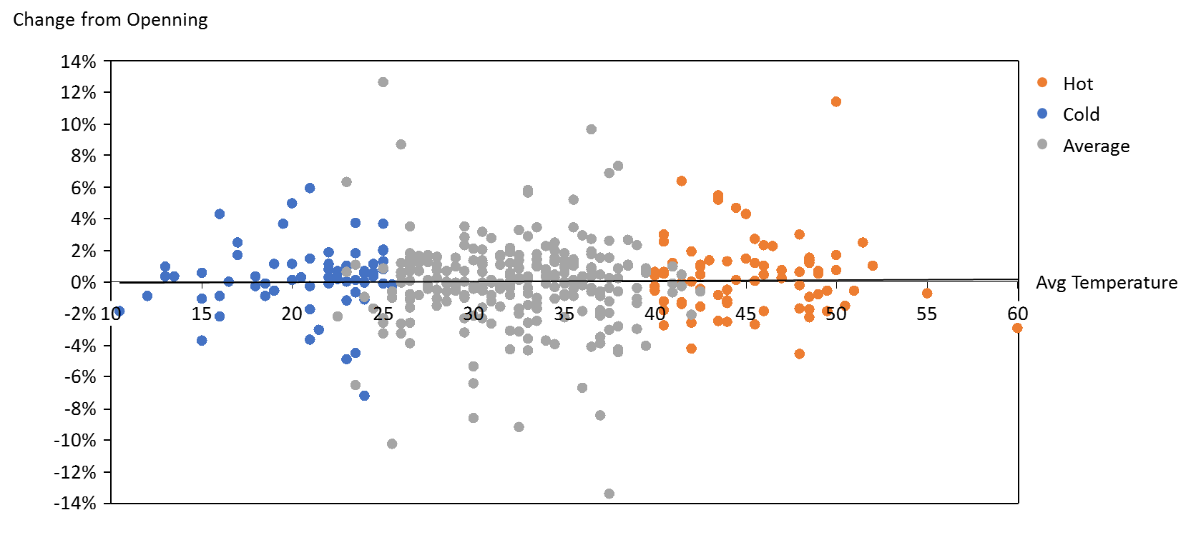

**Table 7 – Winter Change in Temperature and Change in Price Correlations**



**Table 8 – Winter Change in Temperature and Change in Price Regression and Anova**



Spring results were also in line with the rest of my results – no correlation between weather and stock prices. Cluster analysis in chart 7.1 shows even distribution of changes in stock market for any given temperature. Table 9 shows the result of the correlation analysis. Here, correlation between weather and stock prices was almost non-existent, however volume had a bit higher negative correlation. With almost -14% correlation this was the strongest relation in the analysis (though it was negative). Table 10 includes the regression and anova results. The regressions with close to zero R squared indicates very low connection between weather and stock prices. However, while the Anova shows insignificant results for the relation between stock prices and temperature, it shows significant connection between temperature and volume.

In addition, Spring showed a unique behaviour for days that were identified as cold. Chart 7.2 indicates that cold days have stronger relation to stock market. This means that in cold days, the warmer it gets the higher the stock market will be. This trend did not continue in average days or hot days, where the relation remained flat.

**Chart 7.1 – Spring Cluster of Return and Weather**

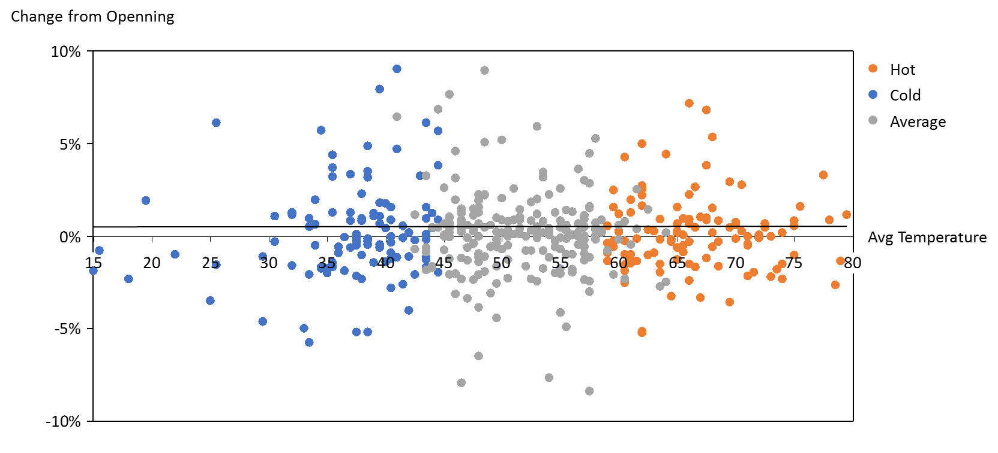

**Table 9 – Spring Change in Temperature and Change in Price Correlations**



**Table 10 – Spring Change in Temperature and Change in Price Regression and Anova**



**Chart 7.2 – Spring Cluster of Return and Weather – Cold Only**

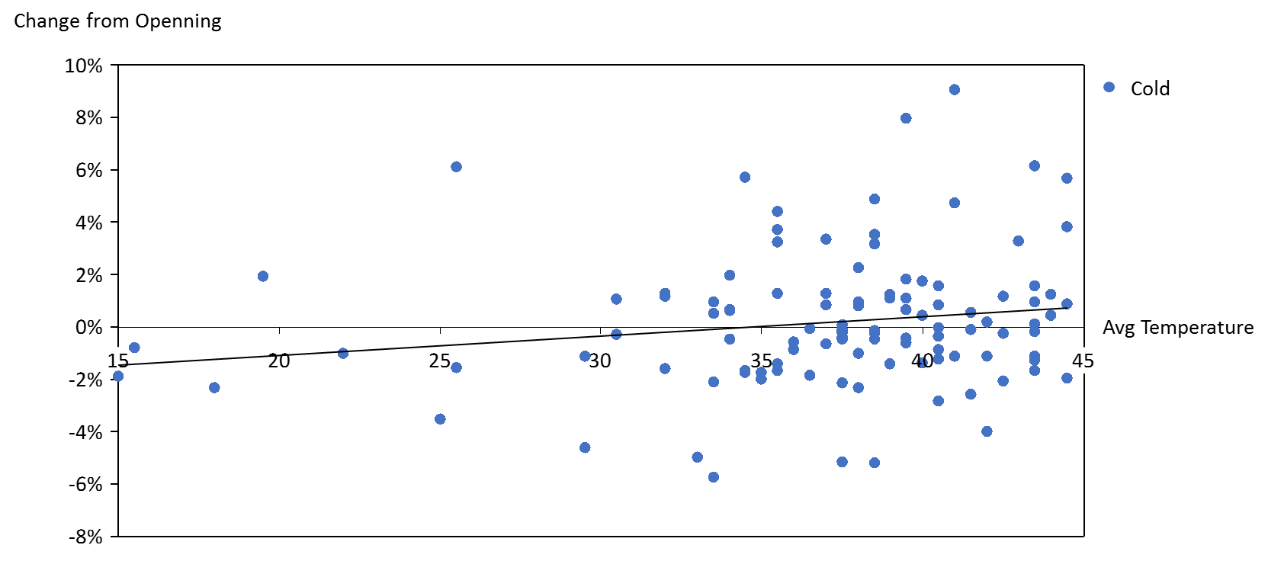

Autumn was no different than winter in its behaviour. No correlation between weather and stock prices was found. Cluster analysis in chart 8 shows even distribution of changes in stock market for any given temperature. The results are so even that is hard to identify the trendline. Table 11 shows the result of the correlation analysis. Here too, correlation was very low at close to zero. Table 12 includes the regression and anova results. The regressions with close to zero R squared indicates very low connection between weather and stock prices. So does the anove with high P value and low degree of confident.

**Chart 8 – Autumn Cluster of Return and Weather**

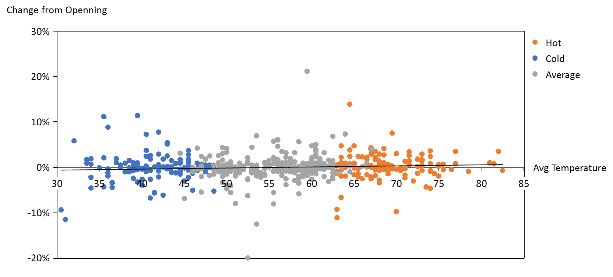

**Table 11 – Autumn Change in Temperature and Change in Price Correlations**



**Table 12 – Autumn Change in Temperature and Change in Price Regression and Anova**



**Conclusion**

Based on my analysis it looks like weather had no impact on the New York (NYSE) stock exchange. While there were a few outliers, such as hot days in the summer, cold days in the summer, and cold days in the spring, that showed slightly stronger relation, they were still not as significant nor very common. Even though my analysis did not show impact in the New York stock exchange it is not necessarily true to all markets. My literature review shows that in some markets weather does have significant impact on stock market returns. There can be multiple reasons for my results. First, as the largest stock exchange in the world, New York attracts people from all around the world and some people may trade from different locations. Second, New York also attracts the most talented and trained traders in the world. Those trades may be well educated and make “cold” decisions, regardless of their mood. Finally, through not likely, weather may have different impact on different people. While some may have negative moods in a cold rainy day, others may flourish. This may alter peoples’ decision and two sides may offset each other.

**References**

Chang, T., Nieh, C., Jing, M., & Yang, T. (2006). Are stock market returns related to the weather effects ? Empirical evidence from Taiwan, *364*, 343–354. https://doi.org/10.1016/j.physa.2005.09.040

Guéguen, N., & Lamy, L. (2013). Weather and helping: Additional evidence of the effect of the sunshine samaritan. *Journal of Social Psychology*, *153*(2), 123–126. https://doi.org/10.1080/00224545.2012.720618

Hirshleifer, D., & Shumway, T. (2003). Good Day Sunshine: Stock Returns and the Weather. *Journal of Finance*, *58*(3), 1009–1032. https://doi.org/10.1111/1540-6261.00556

Kang, S. H., Jiang, Z., Lee, Y., & Yoon, S. M. (2010). Weather effects on the returns and volatility of the Shanghai stock market. *Physica A: Statistical Mechanics and Its Applications*, *389*(1), 91–99. https://doi.org/10.1016/j.physa.2009.09.010

Keller, M. C., Fredrickson, B. L., Ybarra, O., Côté, S., Johnson, K., Mikels, J., … Wager, T. (2005). A warm heart and a clear head: The contingent effects of weather on mood and cognition. *Psychological Science*, *16*(9), 724–731. https://doi.org/10.1111/j.1467-9280.2005.01602.x

Khanthavit, A. (2017). Instrumental-Variable Estimation of Bangkok-Weather Effects in the Stock Exchange of Thailand. *Asian Academy of Management Journal of Accounting & Finance*, *13*(1), 83–111. https://doi.org/10.21315/aamjaf2017.13.1.4

Loughran, T., & Schultz, P. (2004). Weather , Stock Returns , and the Impact of Localized Trading Behavior, *39*(2).

Madsen, J., & Piotroski, J. D. (2016). Do Weather-induced Moods Affect the Processing of Earnings Information? | Stanford Graduate School of Business, (206). Retrieved from https://www.gsb.stanford.edu/faculty-research/working-papers/do-weather-induced-moods-affect-processing-earnings-information

Ong, B. (2016). Weather vs. the Stock Market. *NYC Data Science Academy*.

Saunders, E. M. (1993). Stock and Wall Street Weather.pdf.

Vijayakumar, N., Dharani, M., & Muruganandan, S. (2015). Impact of Weather on Return and Volatility : Evidence From Indian Stock Market. *International Journal of Financial Management*, *5*(2). https://doi.org/10.21863/ijfm/2015.5.2.010

Worthington, A. (2009). An Empirical Note on Weather Effects in the Australian Stock Market*. *Economic Papers: A Journal of Applied Economics and Policy*, *28*(2), 148–154. https://doi.org/10.1111/j.1759-3441.2009.00014.x

Yoon, S. M., & Kang, S. H. (2009). Weather effects on returns: Evidence from the Korean stock market. *Physica A: Statistical Mechanics and Its Applications*, *388*(5), 682–690. https://doi.org/10.1016/j.physa.2008.11.017

Zadorozhna, O. (2009). Does Weather Affect Stock Returns Across Emerging Markets?